UNIT 2- DATA REPRESENTATION

2.1 Introduction to data representation
Data refers to the symbols that represent people, events, things, and ideas. Data can be a name, a number, the colours in a photograph, or the notes in a musical composition. Data Representation refers to the form in which data is stored, processed, and transmitted. Devices such as smartphones, iPods, and computers store data in digital formats that can be handled by electronic circuitry.
Data and instructions cannot be entered and processed directly into computers using human language. Any type of data be it numbers, letters, special symbols, sound or pictures must first be converted into machine-readable form i.e. binary form. Due to this reason, it is important to understand how a computer together with its peripheral devices handles data in its electronic circuits, on magnetic media and in optical devices.
Data representation in digital circuits
Electronic components, such as microprocessor, are made up of millions of electronic circuits. The availability of high voltage(on) in these circuits is interpreted as ‘1’ while a low voltage (off) is interpreted as ‘0’.This concept can be compared to switching on and off an electric circuit. When the switch is closed the high voltage in the circuit causes the bulb to light (‘1’ state).on the other hand when the switch is open, the bulb goes off (‘0’ state). This forms a basis for describing data representation in digital computers using the binary number system.
Reason to use binary system in computer
It has proved difficult to develop devices that can understand natural language directly due to the complexity of natural languages. However, it is easier to construct electric circuits based on the binary or ON and OFF logic. All forms of data can be represented in binary system format. Other reasons for the use of binary are that digital devices are more reliable, small and use less energy as compared to analog devices.
To a computer, everything is a number, i.e., alphabets, pictures, sounds, etc., are numbers. Number system is categorized into four types −
- Binary number system consists of only two values, either 0 or 1
- Octal number system represents values in 8 digits.
- Decimal number system represents values in 10 digits.
- Hexadecimal number system represents values in 16 digits.
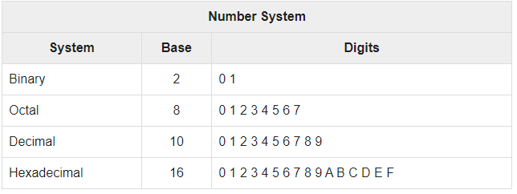
Text Code
Text code is format used commonly to represent alphabets, punctuation marks and other symbols. Four most popular text code systems are −
- EBCDIC (Extended Binary Coded Decimal Interchange Code)
- ASCII
- Extended ASCII
- Unicode
EBCDIC
Extended Binary Coded Decimal Interchange Code is an 8-bit code that defines 256 symbols. Given below is the EBCDIC Tabular column
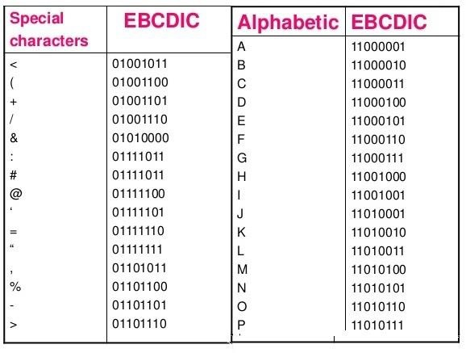
ASCII
American Standard Code for Information Interchange is an 8-bit code that specifies character values from 0 to 127.
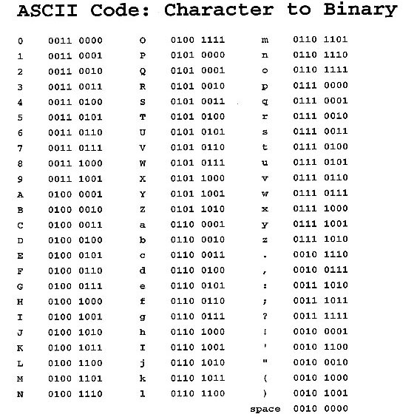
Why is ASCII important? What is ASCII used for?
ASCII is important because it is our link between our computer screen and our computer hard drive, and that link is now the same between all computers. ASCII is used to translate computer text to human text. All computers speak in binary, a series of 0 and 1. However, just like English and Spanish can use the same alphabet but have completely different words for similar objects, computers also had their own version of languages. ASCII is used as a method to give all computers the same language, allowing them to share documents and files. ASCII is important because the development gave computers a common language.
Extended ASCII
Extended American Standard Code for Information Interchange is an 8-bit code that specifies character values from 128 to 255.
Extended ASCII Tabular column
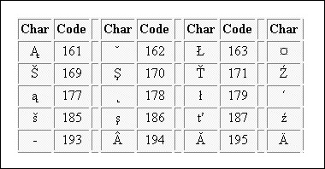
Unicode
Unicode Worldwide Character Standard uses 4 to 32 bits to represent letters, numbers and symbol.
Unicode Tabular Column
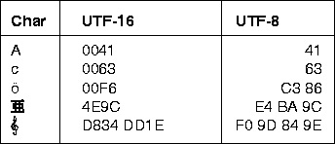

2.2 Unit of Measurement
Bits, bytes, nibble and word
The terms bits, bytes, nibble and word are used widely in reference to computer memory and data size.
Bits: can be defined as either a binary, which can be 0, or 1.It is the basic unit of data or information in digital computers.
A nibble: is half a byte, which is usually a grouping of 4 bytes.
Byte: a group of bits (8 bits) used to represent a character. A byte is considered as the basic unit of measuring memory size in computer.
Word: two or more bits make a word. The term word length is used as the measure of the number of bits in each word. For example, a word can have a length of 16 bits, 32 bits, 64 bits etc.
All of the data stored and transmitted by digital devices is encoded as bits. Terminology related to bits and bytes is extensively used to describe storage capacity and network access speed. The word bit, an abbreviation for binary digit, can be further abbreviated as a lowercase b. A group of eight bits is called a byte and is usually abbreviated as an uppercase B.
When reading about digital devices, you’ll frequently encounter references such as 90 kilobits per second, 1.44 megabytes, 2.8 gigahertz, and 2 terabytes. Kilo, mega, giga, tera, and similar terms are used to quantify digital data. It is use bits for data rates, such as Internet connection speeds, and movie download speeds. It use bytes for file sizes and storage capacities.
Example:
- 100 Gbit: Gigabit (Gb or Gbit) is used for really fast network speeds.
- 16 GB: Gigabyte (GB or GByte) is commonly used to refer to storage capacity.

s.no | Memory unit | Description
1 | Bit | 1 Bit = 0 or 1
2 | Nibble | 1 Nibble = 4 Bits
3 | Byte | 1 Byte = 8 Bits
4 | Kilobyte(KB) | 1 Kilobyte (KB) = 1024 Bytes
5 | Megabyte(MB) | 1 Megabyte (MB) = 1024 KB
6 | Gigabyte(GB) | 1 Gigabyte (GB) = 1024 MB
7 | Terabyte(TB) | 1 Terabyte (TB)= 1024 GB
8 | Petabyte(PB) | 1 Petabyte (PB) = 1024 TB
9 | Exabyte(EB) | 1 Exabyte (EB) = 1024 PB
10 | Zettabyte | 1ZB (Zettabyte)= 1024 EB
11 | Yottabyte | 1YB (Yottabyte)=1024 ZB
12 | Brontobyte | 1BB (brontobyte)= 1024 YB
13 | Geopbyte | 1 GeB(Geopbyte)=1024BB

2.3 Signed number representation
Signed number is required to encode negative numbers in the binary number system .Generally, negative numbers in any base system are written by preceding the number with (-) Sign.
As (- 123) (+ 123)
But Computer does not support directly minus sign with negative number.
There are three standard ways to represent negative numbers:
- Sign and magnitude technique
- One’s Complement representation
- Two’s Complement Method

2.3.1 Sign and magnitude technique
Number is represented as 8-bit or 16-bit combination where left most bit (MSB- most significant bit) is represented as sign bit and rest bit is magnitude bit.
In 8- bit representation (1 bit for sign and 7 –bit for magnitude)
In 16 –bit representation (1 bit for sign and 15 bit for magnitude)
If the MSB be 0 the number is Positive.
If the MSB be 1 the number is Negative
For example: +36 = 0 0100100
-45 = 1 0101101
+117= 0 1110101
-117 = 1 1110101
But, this technique is not proper because there is no proper system to represent negative number.

2.3.2 One’s complement representation
In this technique, negative number is obtained by taking the complement of its positive counterpart.
Also, we can say 1’s compliment of a binary number is obtained by flipping all bits.
For example: +45 = 0 0101101
Complement each binary digit for negative value
- 45 = 1 1010010
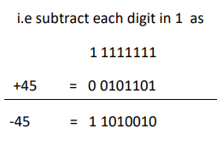
But this technique is not well defined and meaningful because the representation of -0 and +0 is different form as –
+0 = 0 0000000
-0 = 1 1111111
So, another technique adopted that are universal for all numbers.
TRICK: To change binary number into 1s compliment. Convert 0 into 1 and 1 into 0.
e.g. binary of +24 is 11000. Now 1s compliment of negative value -24 is 00111.

2.3.3 Two’s complement representation
In this technique , first the negative number is represented in One’s Complement then add 1 to least significant bit(LSB) i.e. right most bit.
For example
+45 = 0 0101101
-45 = 1 1010010 - in One’s Complement
+1
_____________________
11010011 - 2’s Complement
Converting positive value to 2’s complement.
TRICK: Leave all bit up to first 1-bit of positive binary value as it appear from LSB(least significant bit) then complement the rest of the bit , the result will be the negative value.
+44 = 0 0101100
-44 = 1 1010100 -- in 2’s Complement.
+45 = 0 0101101
-45 = 1 1010011. Similarly the system is worked in rest of the number system

2.4 Floating Point Representation
A number without a fixed number of digits before and after the decimal point is called floating point.
Floating point refers to the fact that a number’s radix point can float, that is, it can be placed anywhere relative to the significant digits of the number.
e.g. number is 100.00 1000.0 x 10⁻¹
100.0 1.0 x 10²
2.0 x 10⁻⁴ 0.0002
1001.010 10010.10 x 2⁻² / 1.001010 x 2³
To convert the floating point into decimal, we have 3 elements in a floating point representation:
i) Sign
ii) Exponent
iii) Mantissa
The general structure of floating point is = M * B^{nE}.
Where M stands for mantissa. B stands for radix. Example for binary value of B is 2 and value of decimal is 10 etc. n stands for sign (positive or negative) and E stands for exponent.
Let us consider the number 1 1 1 1 0 1. 1 0 0 0 1 1 0 to be represent in the floating point format.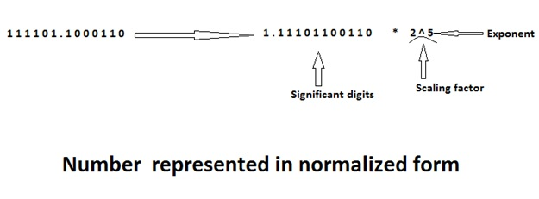
To represent the number in floating point format, the first binary point is shifted to the right of the first bit and the number is multiplied by the correct scaling factor to get the same value. The number is said to be in the normalized form.
It is important to note that the base in the scaling factor is fixed 2.
The string of the significant digits is commonly known as mantissa.
In the above example, we can say that,
Sign = 0
Mantissa = 1 1 1 0 1 1 0 0 1 1 0
Exponent =5
In floating point numbers, the bias value is added to the true exponent. This solves the problem of representation of negative exponent.
IEEE 754 Standards for Floating Point Numbers
The standards for the representation of floating point numbers in 32 bits and 64 bits have been developed by the Institute of Electrical and Electronics Engineers (IEEE), which is referred to as IEEE 754 standards.
32 bits
The standard representation of floating point number in 32 bits is called as a single precision representation because it occupies a single 32 bit word. The 32 bits divided into three fields:
  - (Field 1) Sign = 1 bit
  - (Field 2) Exponent = 8 bits
  - (Field 3) Mantissa = 23 bits
Instead of the signed exponent E, the value actually stored in the exponent field is E' = E (Scaling factor) + bias. In the 32 bit floating point system (single precision), bias is 127.
Now, normalize structure of 32 bits will be: (1.N) 2 ^{E’}. Where 1 stands for sign, N stands for binary number and E’= E+ bais. (bais value is 127)
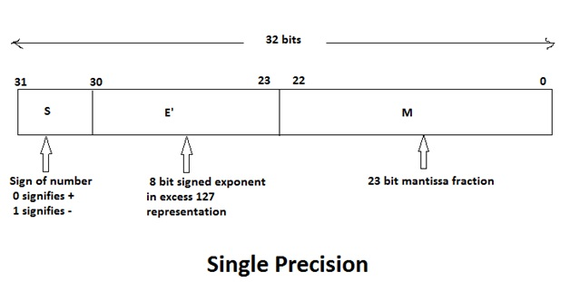
64 bits
The 64 bit standard representation is called a double precision representation because it occupies two 32 bit words.
The 64 bits are divided into three fields:
  - (Field 1) Sign = 1 bit
  - (Field 2) Exponent = 11 bit
  - (Field 3) Mantissa = 52 bits
In the double precision format value actually stored in the exponent field is given as E' = E + 1023 Here, bias value is 1023 and hence it is also called excess 1023 format.
Now, normalize structure of 64 bits will be: (1.N) 2 ^{E’}. Where 1 stands for sign, N stands for binary number and E’= E+ bais. (bais value is 1023)

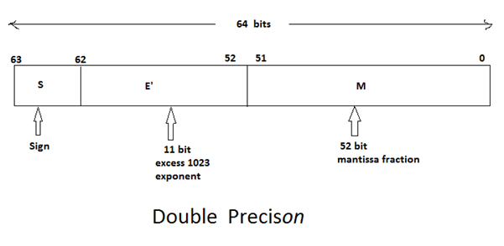
Example:
IEEE 754 standard for given number: 1.00010100 * 2⁻¹⁰
Here
sign= 0
mantissa= 00010100
E’= E+ bais = -10+127 = 117₁₀ 1110101 (in binary)
Here 117 is in decimal form, so it is changed into binary form.
Now, the final answer is:
0 | 01110101 | 000101000000000000000000
1 bit 8 bits 23 bits
Here, 0 is added in mantissa after Least significant bit (after last value) to comply with 23 bits. And zero is added before Most significant bit (before first value) to comply with 8 bits.
Example 2:
Represent (1259.125)₁₀ in single and double precision.
STEP 1: convert decimal number in binary
1259 10011101011
0.125 001
0.125 *2 = 0.250 , 0.250 * 2= 0.500 , 0.500 *2 = 1.000
Multiply until whole number is found, after whole number is found, now equivalent of 0.125 will be 001.
(1259.125)₁₀ (10011101011.001)₂
Step 2: normalize the number.
10011101011.001 1.0011101011001 x 2¹⁰
Here
sign= 0
mantissa= 0011101011001
E’= E+ bais = 10+127 = 137₁₀ 10001001 (in binary)
Now, the final answer is: (in 32 bits)
S E’ M
0 | 10001001 | 00111010110010………00
1 bit 8 bits 23 bits
Now, in double precision
sign= 0
mantissa= 0011101011001
E’= E+ bais= 10+1023= 1033 (10000001001)₂
Now, the final answer is: (in 64 bits)
S E’ M
0 | 10000001001 | 00111010110010………00…
1bit 11 bits 52 bits

2.5 BCD (binary coded decimal)
BCD or binary-coded decimal is a special kind of representation of a decimal number in binary numbers. In BCD, each digit is represented by a fixed number of binary bits, usually between four and eight. The norm is four bits, which effectively represent decimal values 0 to 9. In binary-coded decimal each individual digit of a number is converted into a binary number, and then by combining them all, the BCD code is generated. But always remember that a binary-coded decimal is not a binary representation of a decimal number. Numbers larger than 9, having two or more digits in the decimal system, are expressed digit by digit. For example, the BCD rendition of the base-10 number 1895 is
0001 1000 1001 0101
Example:
The BCD or binary-coded decimal of the number 15 is 00010101. The 0001 is the binary code of 1 and 0101 is the binary code of 5.

